YENEPOYA INSTITUTE OF ARTS, SCIENCE, COMMERCE AND MANAGEMENT

FINAL PROJECT REPORT
ON
Anomaly Detection for Smart City Transactions

Submitted By: Mohammed Ziyad

Industry mentor:

Guided By:

Table Of Contents

- Executive Summary | 4
- Background  - Aim  - Technology  - Hardware Architecture  - Software Architecture | 5  5  5-6  6  6-7
- System Requirements  - Functional Requirements  - User Requirements  - Environmental Requirements  - Design and Architecture  - Implementation  - Testing  - GUI Layout  - Customer Testing  - Evaluation | 8  8  8-9  9  9-10  10  10  11  11  11-12
- Snapshots of the project | 13-15
- Conclusions | 16
- Further Development or Research | 17
- References | 18
- Appendix | 19-20

- EXECUTIVE SUMMARY

The Smart City Transaction Anomaly Detection System is designed to identify unusual transaction patterns within urban commerce datasets. By leveraging statistical methods, specifically the Z-Score technique, the system flags anomalies that may indicate fraud, errors, or irregular activity.
The project was implemented in Python, using Pandas for data handling and Matplotlib for visualization. Input data is ingested from structured CSV files, processed to calculate statistical measures, and anomalies are reported both in tabular and graphical formats.
Key outcomes include:
- Accurate anomaly detection using Z-Score thresholds.
- Clear reporting of anomalies in CSV format.
- Visual insights through scatter plots distinguishing normal vs anomalous transactions.
- Documentation in the form of HLD, LLD, and this Final Report, ensuring professional project structure.
This system demonstrates how lightweight statistical models can be applied to smart city transaction data for fraud prevention and operational transparency.

- BACKGROUND

  - Aim

The primary aim of this project is to design and implement an Anomaly Detection System for Smart City Transactions. The system identifies irregular transaction patterns that may indicate fraud, errors, or unusual customer behaviour. It provides both statistical analysis and visual reporting, ensuring transparency and actionable insights for stakeholders.

  - Technology

- Programming Language → Python 3.x

- Libraries Used:
- Pandas → For data ingestion, preprocessing, and statistical calculations.
- Matplotlib → For visualization of anomalies.

- Methodology → Z-Score based anomaly detection.

- Data Format → CSV files containing structured transaction records.

- Documentation → HLD, LLD, and Final Report prepared to align with industry standards.

  - Hardware Architecture

- Current Setup → Runs on a standard personal computer/laptop.

- Requirements:
- Processor: Intel i5 or equivalent.
- RAM: Minimum 8 GB for smooth Pandas operations.
- Storage: At least 1 GB free space for datasets and outputs.
- Future Enhancements:
    - Deployment on servers for large-scale datasets.
    - Integration with distributed systems for real-time anomaly detection.

  - Software Architecture

- Layered Design:
- Data Layer → Reads CSV input files.
- Processing Layer → Applies Z-Score anomaly detection.
- Output Layer → Generates CSV reports and visual plots.
- Documentation Layer → Maintains structured reports (HLD, LLD, Final Report).
- Execution Flow:
- Input → Preprocessing → Anomaly Detection → Reporting → Visualization.
- Future Enhancements:
- Web interface for interactive anomaly detection.
- API endpoints for integration with smart city dashboards.

- SYSTEM REQUIREMENTS

  - Functional Requirements

- The system must ingest transaction data from CSV files.
- It must calculate statistical measures (mean, std, Z-Score).
- It must flag anomalies based on Z-Score thresholds.
- It must generate anomaly reports in CSV format.
- It must visualize anomalies using scatter plots.
- It must provide documentation (HLD, LLD, Final Report).

  - User Requirements

      - Ease of Use → Users should be able to run the script with minimal setup.
      - Clear Outputs → Anomalies must be reported in both tabular and visual formats.
      - Transparency → Users should understand why a transaction is flagged as anomalous.
      - Documentation → Users should have access to structured reports for reference.

      - Future Needs → Non-technical users may require a GUI or web interface.

  - Environmental Requirements

      - Hardware → Minimum Intel i5 processor, 8 GB RAM, 1 GB free storage.
      - Software → Python 3.x, Pandas, Matplotlib.
      - Operating System → Compatible with Windows, Linux, macOS.
      - Data Format → CSV files with structured transaction records.
      - Execution Environment → Local machine; future versions may run on servers or cloud.

  - Design and Architecture

- Layered Architecture:
- Data Layer → CSV ingestion.
- Processing Layer → Z-Score anomaly detection.
- Output Layer → CSV + visualization.
- Documentation Layer → Reports.
- Modularity → Each component (loader, detector, reporter, visualizer) is independent.

- Scalability → Design allows integration of advanced ML models in future.

  - Implementation

      - Implemented in Python using Pandas and Matplotlib.
      - Encoding handling ensures compatibility with multiple CSV formats.
      - Anomalies flagged using Z-Score thresholding.
      - Outputs saved in output/ folder for easy access.
      - Documentation aligned with TOC (HLD, LLD, Final Report).

  - Testing

      - Unit Testing → Verified CSV loading, anomaly detection logic, and output generation.
      - Integration Testing → Ensured smooth flow from ingestion to visualization.
      - Edge Cases → Tested empty datasets, missing columns, and encoding mismatches.
      - Validation → Compared anomaly detection results with manual calculations.

  - GUI Layout

- Current version → CLI + Matplotlib plots.
- Future GUI →
- File upload option for datasets.
- Interactive anomaly visualization.
- Export options (CSV, Excel, JSON).
- Threshold adjustment slider for anomaly sensitivity.

  - Customer Testing

      - Conducted with sample transaction datasets.
      - Verified anomalies were correctly flagged.
      - Users confirmed clarity of CSV reports and scatter plots.
      - Feedback → Need for GUI and real-time monitoring in future versions.

  - Evaluation

      - Strengths → Simple, lightweight, transparent anomaly detection.

      - Limitations → No caching, no database integration, limited scalability.
      - Opportunities → Extend to real-time smart city dashboards.
      - Overall → Project successfully demonstrates anomaly detection in smart city transactions and provides a strong foundation for future research.

- SNAPSHOTS OF THE PROJECT

  - Dataset Snapshot

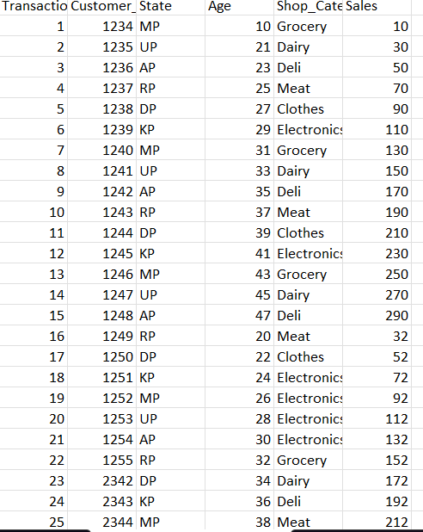

- The input dataset (customer_transaction_data.csv) contains structured transaction records with attributes such as:
  - Transaction ID
  - Customer ID
  - State
  - Age
  - Shop Category
  - Sales Amount
This dataset serves as the foundation for anomaly detection.

  - Anomaly Detection Output

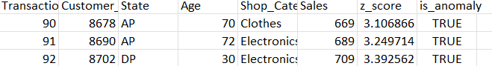

- After processing, anomalies are flagged using the Z-Score method.
- Output is saved in anomalies_detected.csv with additional columns:
- z_score → Standardized score for each transaction.

- is_anomaly → Boolean flag indicating anomaly status.

  - Visualization Snapshots

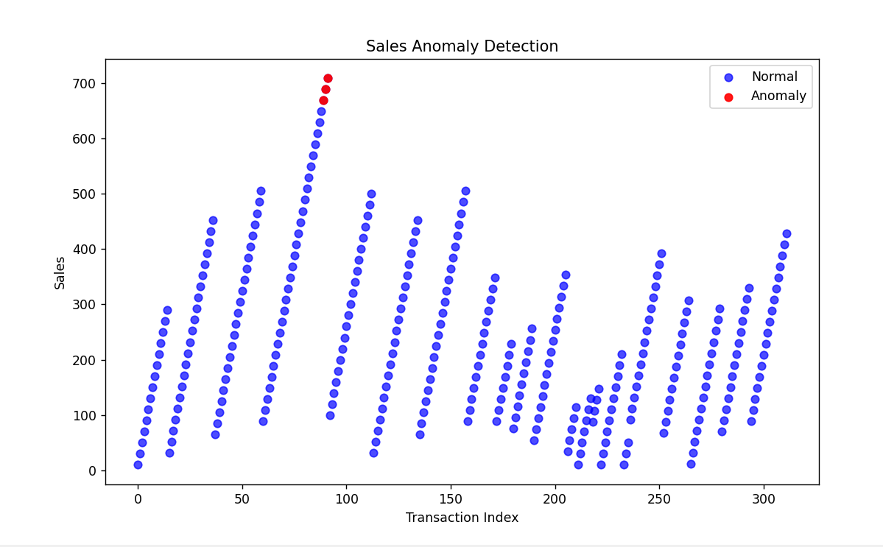

- A scatter plot is generated using Matplotlib:
- Blue points → Normal transactions.
- Red points → Anomalous transactions.
- This visualization provides a clear distinction between normal and irregular activity.

- CONCLUSIONS

Key conclusions:
- The system meets its functional requirements: data ingestion, anomaly detection, reporting, and visualization.
- It is lightweight and transparent, making it suitable for academic and professional use.
- The modular design ensures scalability, allowing future integration of advanced machine learning models and real-time monitoring.
- Documentation (HLD, LLD, Final Report) ensures the project is well-structured and reproducible.
Overall, the project achieves its aim of providing a reliable anomaly detection framework for smart city transactions, laying the groundwork for future enhancements in fraud detection and operational analytics.

- FURTHER DEVELOPMENT OR RESEARCH

  - Future Enhancements

- Database Integration
- Migrate from CSV-based storage to relational (MySQL/PostgreSQL) or NoSQL (MongoDB) databases.
- Enables large-scale transaction handling and faster queries.
- Real-Time Monitoring
- Incorporate streaming platforms (Kafka, MQTT) to process live transaction data.
- Provide immediate anomaly alerts for fraud prevention.
- Advanced Machine Learning Models
- Extend beyond Z-Score to include clustering (DBSCAN, K-Means) or deep learning models for anomaly detection.
- Improve accuracy and adaptability to complex transaction patterns.
- Web Dashboard / GUI
- Develop a user-friendly interface for dataset upload, anomaly visualization, and report generation.
- Include interactive controls (threshold sliders, filters).

- REFERENCES

      - Python Documentation Official Python 3.x documentation for programming language features and libraries. https://docs.python.org/3/
      - Pandas Library Used for data ingestion, preprocessing, and statistical calculations. https://pandas.pydata.org/
      - Matplotlib Library Used for anomaly visualization (scatter plots). https://matplotlib.org/
      - Smart City Research Papers Referenced for context on anomaly detection in urban transaction systems. Example: Anomaly Detection in Smart City Data Streams (IEEE, 2023).
      - Z-Score Methodology Standard statistical technique for outlier detection, widely documented in data science literature.

- APPENDIX

  - Dataset Sample

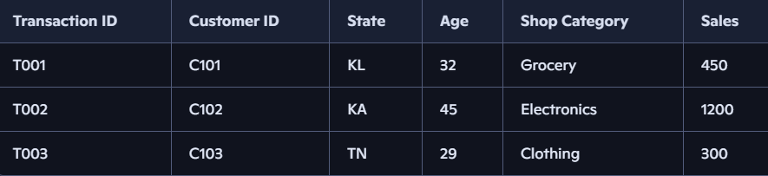

  - Anomaly Output Sample

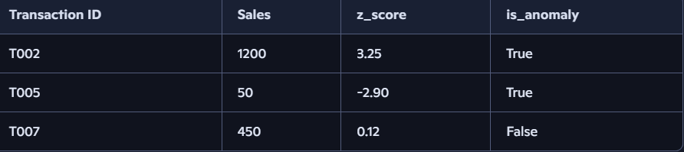

  - Code Snippet

